**Create DB2 and connect python**

|  |  |
| --- | --- |
| Date | 11 November 2022 |
| Team ID | PNT2022TMID07485 |
| Project Name | Smart Fashion Recommender Application |

**CREATING IBM DB2**

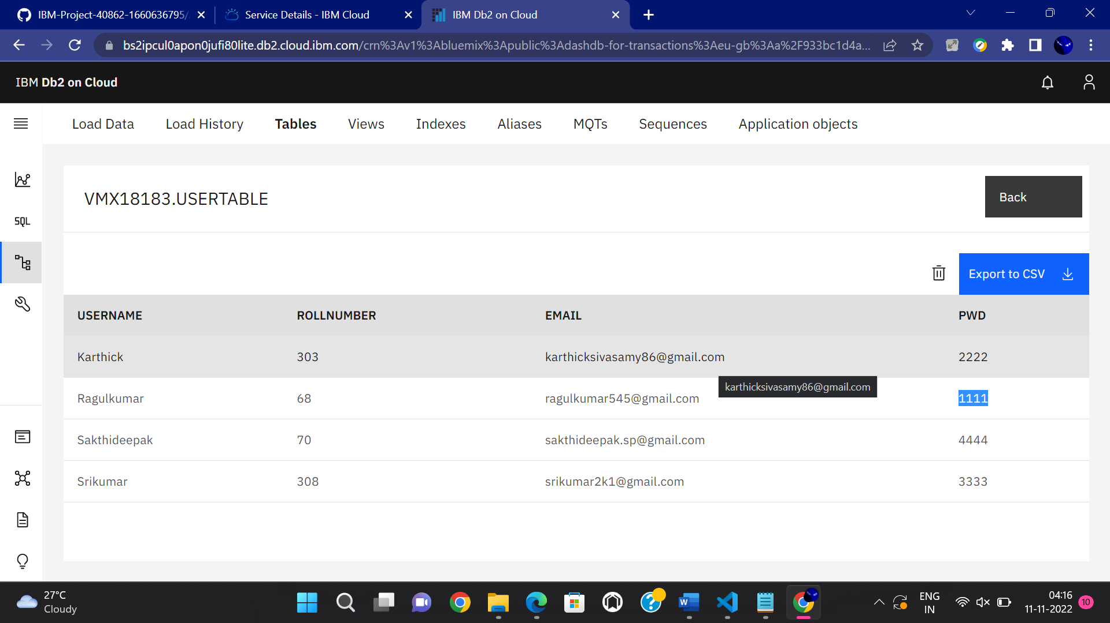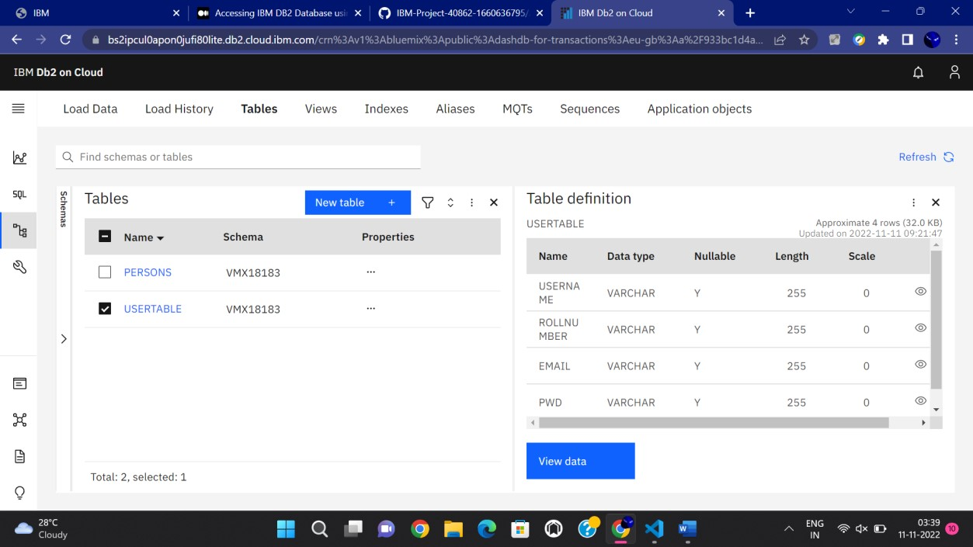

**CONNECT WITH PYTHON CODE**

